**Annex G: Testing the Filled and Sealed Pratt Pouch**

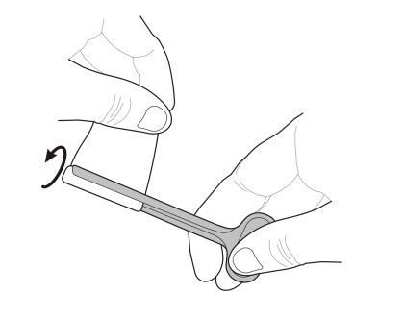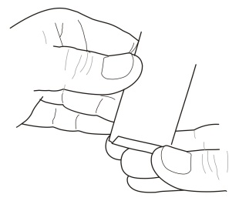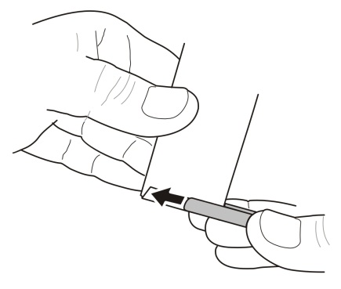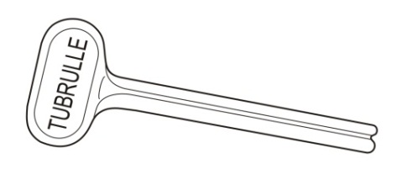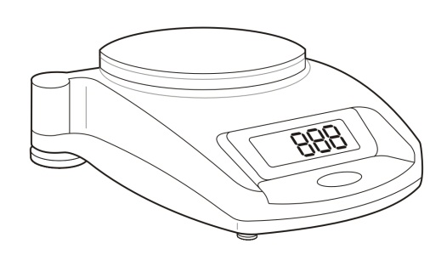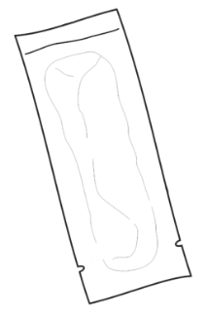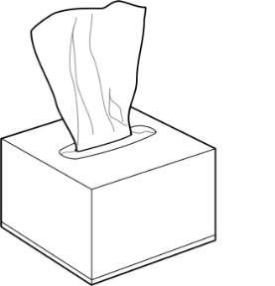**[](https://portal.intrahealth.org/Departments/Communications/Image%20Library/IntraHealth%20logo/IntraHealth%20Logo%20for%20Documents%20in%20Word%20and%20PPT.jpg)**

Fig. 2

Fig. 1

Fig. 3

Handle

Slot

**Tissue Box**

**Scale**

**Filled/sealed  
Pratt Pouch**

**Squeeze device**

Bottom edge

Seal

Tearing notches

**2.1 Fold over** the bottom edge of the pouch at the tearing notches as shown (**Figure 1**). Crease fold so pouch stays folded.

**2.2 Slide** the folded area of the pouch (double thickness) into the slot   
of the squeeze device (**Figure 2**).

**2.3 Holding** the pouch tightly in place against the squeeze device, slowly rotate the device until the pouch contents are fully compressed into the top of the pouch (**Figure 3**).

**Part 2**: Burst Testing the Seal

**Part 1**: Assemble all Supplies

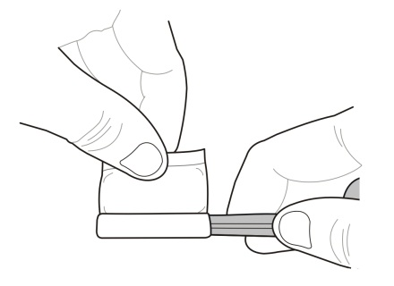

**2.4 Very firmly** hold the device/pouch in the fully-compressed position for   
5 seconds (**Figure 4**).

.

**2.5** If any of the pouch **contents become visible** during Step 2.4, the seal has been broken and the pouch has failed.



Fig. 4

**3.4** If any of the pouchesare **outside of the acceptable weight range,** they were NOT filledcorrectly and have failed the burst test.

**3.3** If the pouches are **within the acceptable weight range,** they were filled  
correctly and have passed the burst test.

**Acceptable weight range for 1.1 ml of NVP: 1.80- 1.91 grams  
Acceptable weight range for 2.2 ml of NVP: 2.89- 3.12 grams**

**Acceptable weight range for 1.1 ml of AZT: 1.91- 2.04 grams   
Acceptable weight range for 2.2 ml of AZT: 3.12- 3.38 grams**

**Acceptable weight range for 1.1 ml of water: 1.75 — 1.86 grams   
Acceptable weight range for 2.2 ml of water: 2.79—3.01** **grams**

**3.1 Weigh** each filled/sealed pouch individually to determine if its contents fall in the acceptable range. (**Figure 6**).

**Part 3**: Verifying the Volume of Pouch Contents

**2.6** If the pouch **seal remains dry** during Step 2.4, the pouch was sealed   
correctly and has passed the burst test.